General Terms & conditions
amsterdam&partners Mediabank

1. Applicability of these Terms & Conditions
These Terms & Conditions apply whenever the website mediabank.iamsterdam.com is used or accessed. By using this website, you indicate that you agree to comply with the Terms & Conditions as written below.
2. Ownership
This website is owned and managed by amsterdam&partners. amsterdam&partners makes images accessible via the amsterdam&partners Mediabank for the illustration of (positive) articles and messages about the Amsterdam Area. amsterdam&partners is not responsible for the images published on the amsterdam&partners Mediabank.
3. Access and availability
The Mediabank is a non-profit website that offers free photos and videos of the Amsterdam Area. The images may be downloaded for editorial or copyright-free use in the promotion of the Amsterdam Area.
You must log in to download images. amsterdam&partners cannot guarantee that the amsterdam&partners Mediabank will be accessible at all times. It is possible that due to circumstances outside amsterdam&partners’s control the Mediabank may become temporarily inaccessible. In such cases, amsterdam&partners will do everything in its power to ensure the website is accessible again as quickly as possible.

A limited amount of accounts is available in our amsterdam&partners Mediabank. Therefore we will be obliged to delete your account after one month of inactivity.
4. Using the images
amsterdam&partners makes a distinction between editorial and copyright-free use. Editorial images in the Mediabank may be used only for non-commercial purposes. This means that these images may be used only for non-profit projects and initiatives and are intended only for journalists, students and educational purposes.
We consider ‘editorial use’ to be when a photo or video is used to illustrate an informative or news-related text or video about the Amsterdam Area. It is important that the publication does not generate profit. You may not use these photos for private, commercial, business, promotional or advertising purposes.
Copyright-free images may – in addition to editorial use – also be used for other purposes, such as brochures, flyers, folders, websites, etc., as long as such use is related to promoting the Amsterdam Area.
For example when you use an image as print for merchandise to sell, like this:
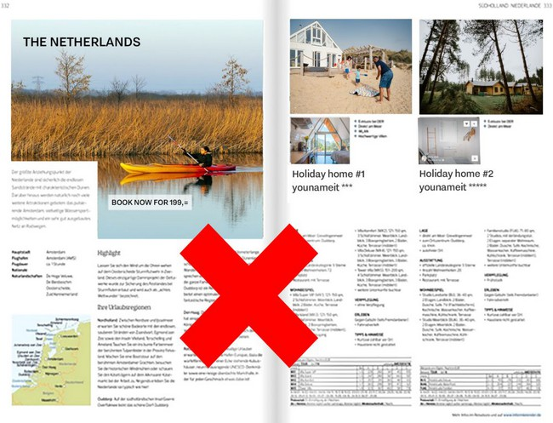

Editorial use on the other hand is allowed. The left page contains text about The Netherlands and where you can go Back to nature. Although the page next to it contains an offer, the picture itself refers to the text on the same page, in this text there is no direct reference to the page on the right side and the text is meant to inform/inspire The Netherlands but not to sell directly.
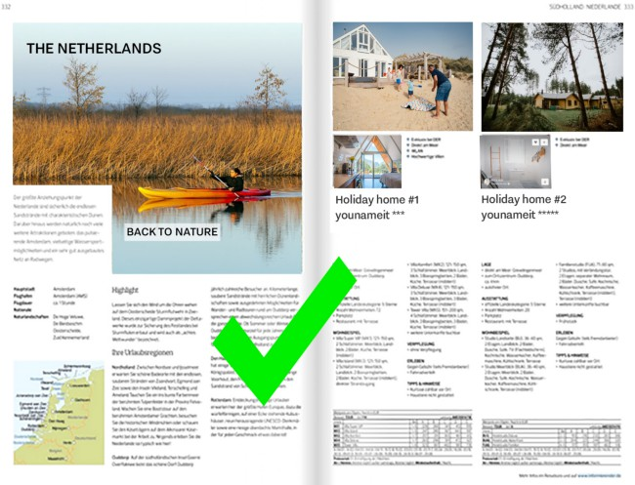
5. Credit
All images may be used only when the name of the photographer and/or source is credited in their publication. Should you neglect to comply with this condition, amsterdam&partners reserves the right to end your access to the Mediabank.
6. Protection of information
You must create an account to download images from the amsterdam&partners Mediabank. In doing so, you indicate that the information you are providing is true and accurate, and that it complies with these Terms & Conditions. Your information is only used for the purpose for which it was provided, that is to provide you access to the Mediabank. This information will not be provided to third parties.
7. Liability
amsterdam&partners is not liable for the unlawful use of the photo and video material provided.
8. Copyright infringement
Any use of an image or video that violates these Terms & Conditions will be considered an infringement on the rights of the photographer. You can, therefore, be held liable by the rights holder(s). You will be held liable for any costs or damages associated with activities that violate these Terms & Conditions (including compensation for any and all direct and indirect damages and all associated legal and other costs).
9. Governing law & jurisdiction
These Terms & Conditions are governed by Dutch law, and all disputes arising out of these terms will be settled in the court system of Amsterdam, the Netherlands.
10. Changes to the Terms & Conditions
amsterdam&partners reserves the right to modify or update these Terms & Conditions or add additional provisions. Updates, changes and/or additions go into effect the moment that they are published on the amsterdam&partners Mediabank.
11. In conclusion
Should specific sections of these Terms & Conditions no longer apply, this does not affect the legality of other sections or the Terms & Conditions as whole.
Questions or comments?
Send an email to mediabank@iamsterdam.com

